I certify that all solutions are entirely in my own words and that I have not looked at another student’s solutions. I have given credit to all external sources I consulted.



2.



a) reconstruction losses on the train sets = 0.7374

reconstruction losses on the validation sets = 0.7427

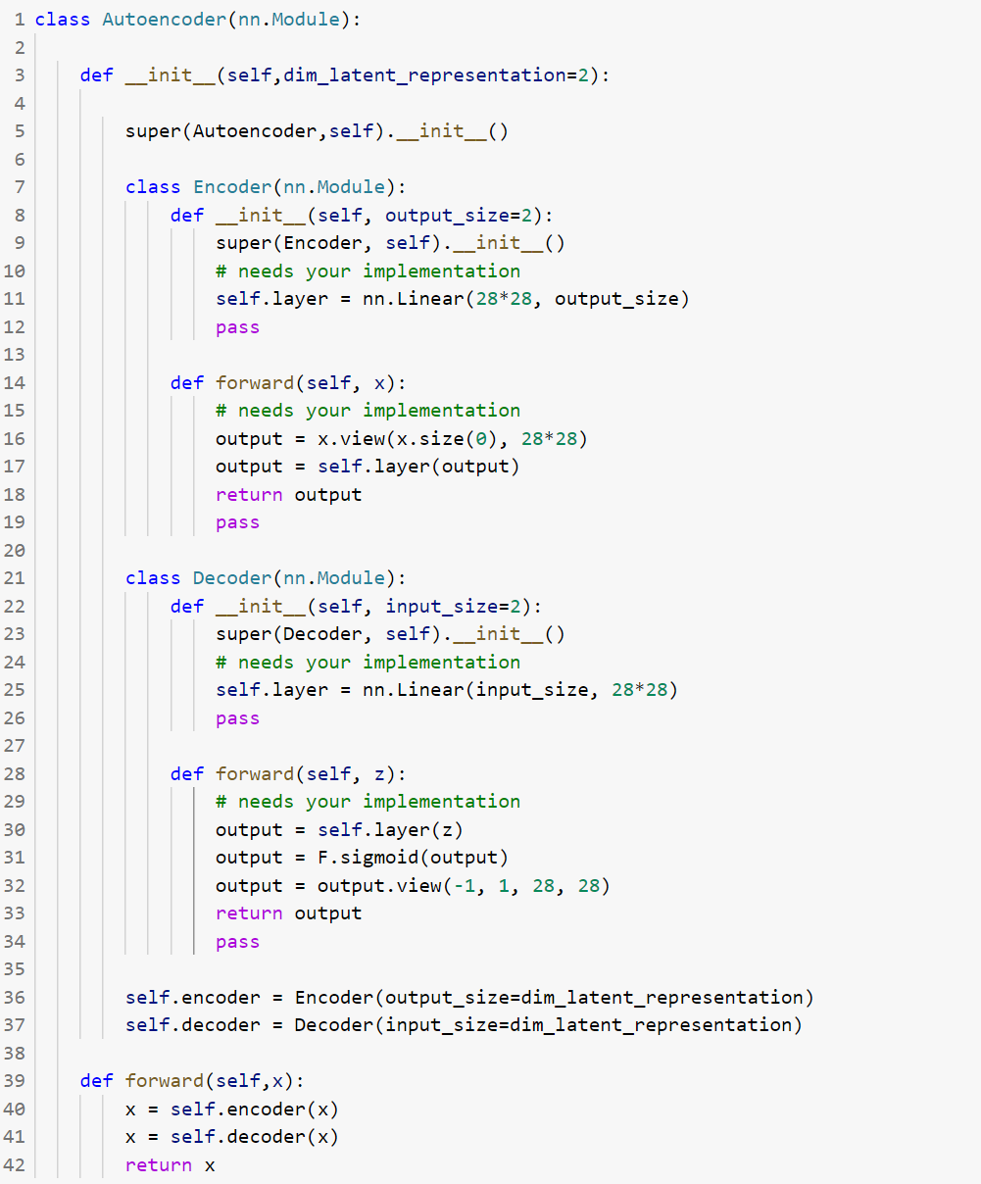

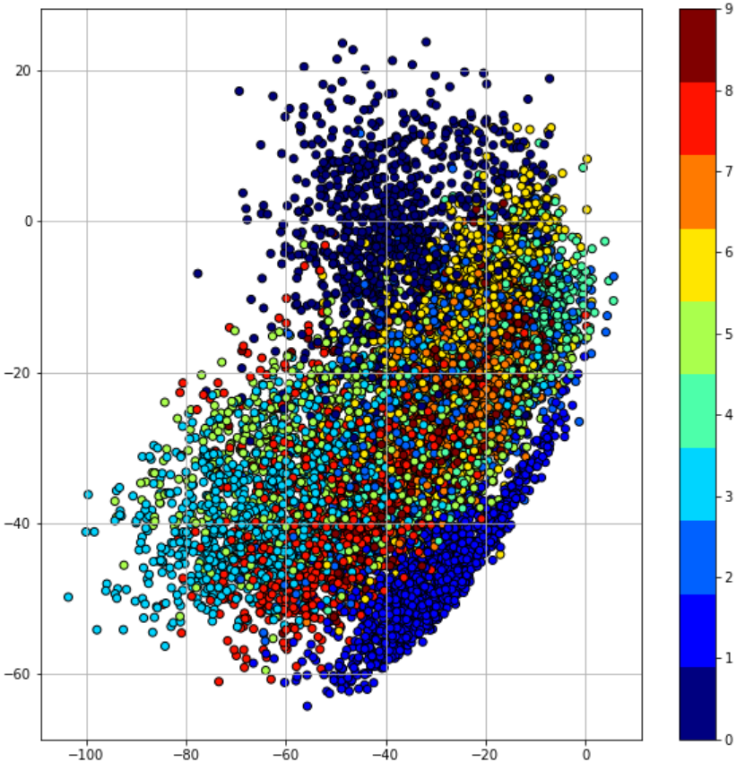

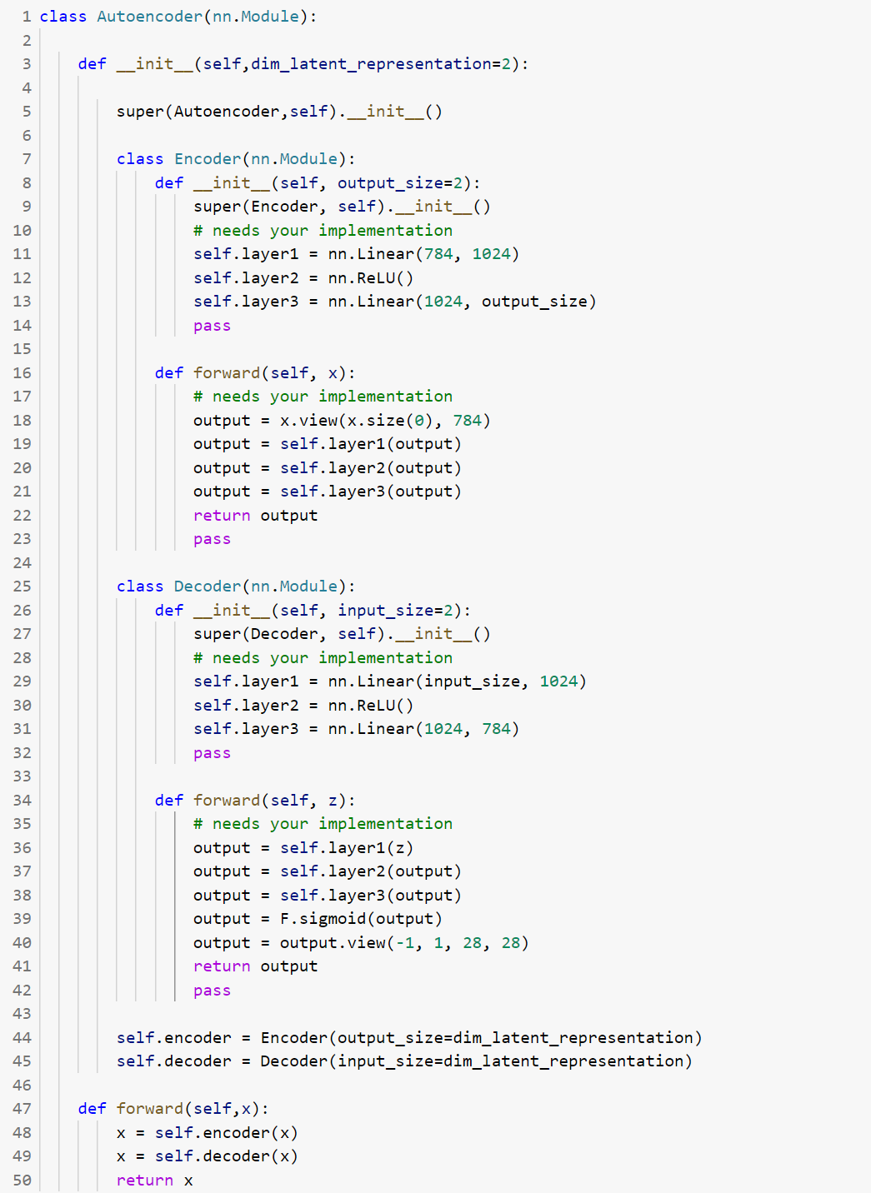b) reconstruction losses on the train sets = 0.6703

reconstruction losses on the validation sets = 0.6773

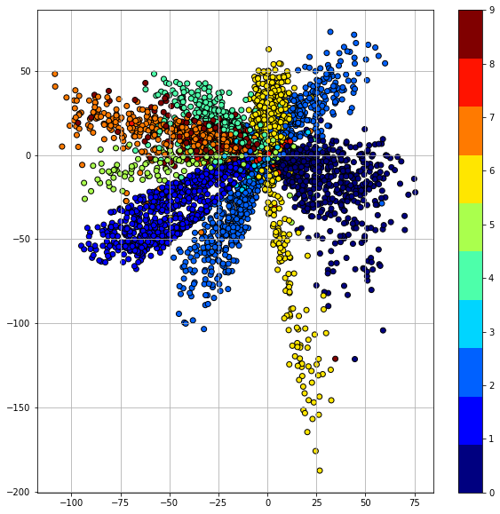

The plot in part a is more random than in part b, the points in part b are getting closer to (0, 0). The architecture in part b is more accurate than part a, because it has more layers.

c) reconstruction losses on the train sets = 0.5259

reconstruction losses on the validation sets = 0.5387

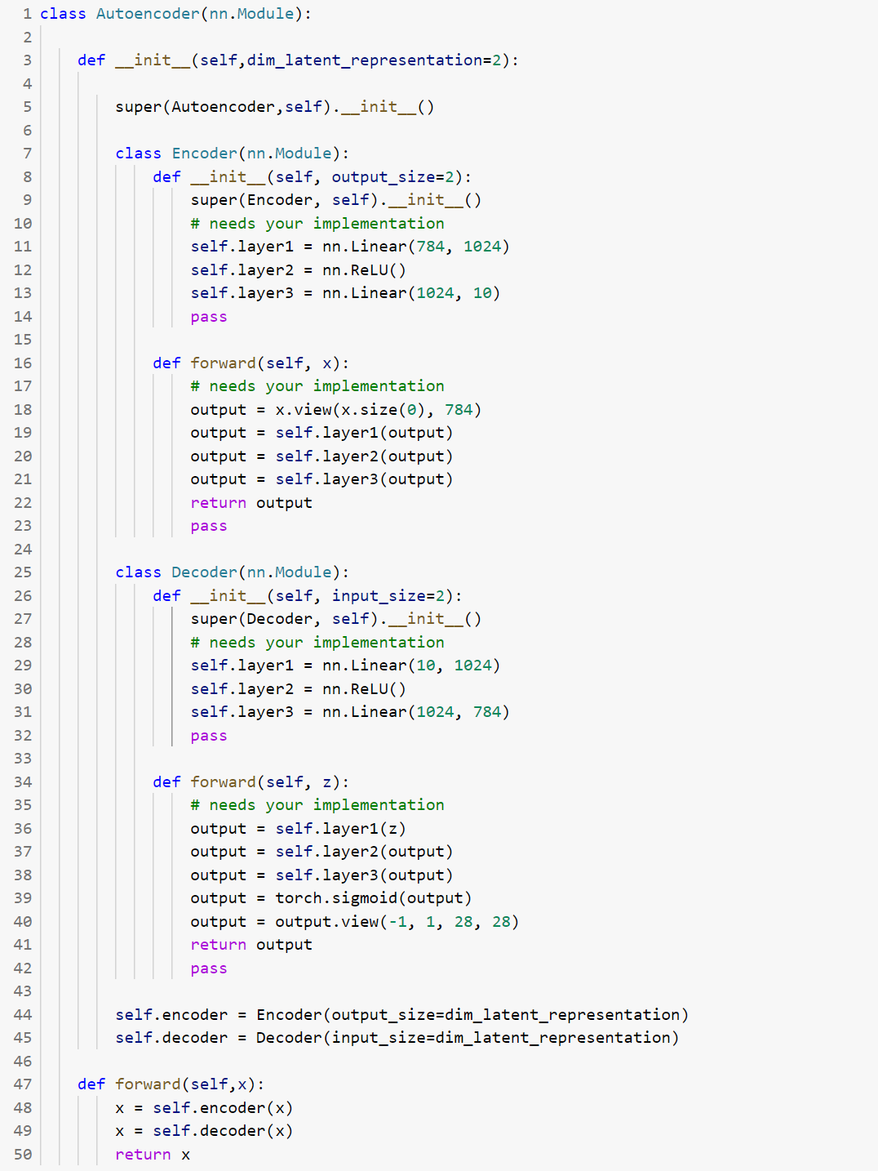

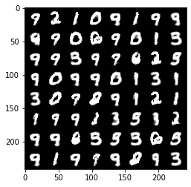

bottleneck feature with 2 dimensions

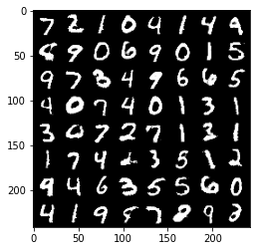

bottleneck feature with 10 dimensions

The image in part c is more accurate than part b compares to the original image, because the bottleneck feature in part c has more dimensions.

d)

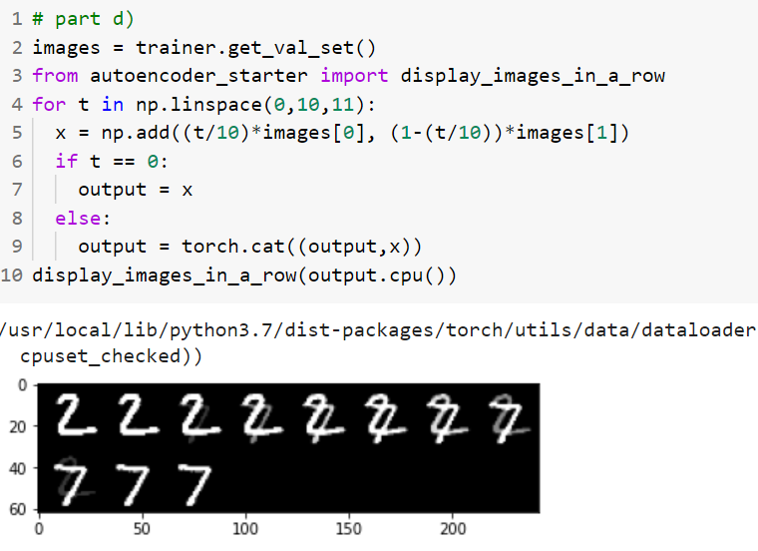

e)

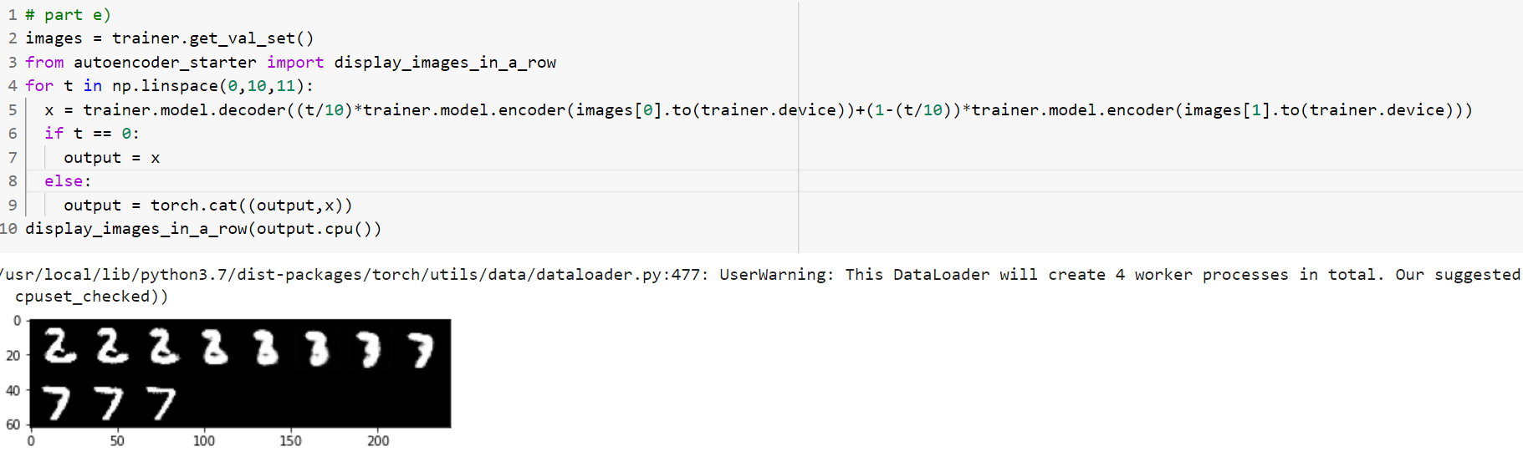

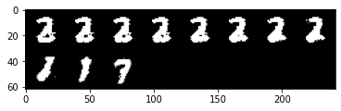

Model from part b

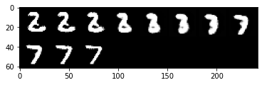

Model from part c

These image in bottleneck feature space are more like a single number, the images in raw pixel space from part (d) are more like two numbers combiner together. I think this is because part e used the encoder and decoder, the decoder can convert some random bottleneck feature to an image of a single number. The image of model from part c is more like numbers than the model from part b, because it has more dimensions, accuracy is higher.

f) reconstruction losses on the train sets = 0.4810

reconstruction losses on the validation sets = 0.4926

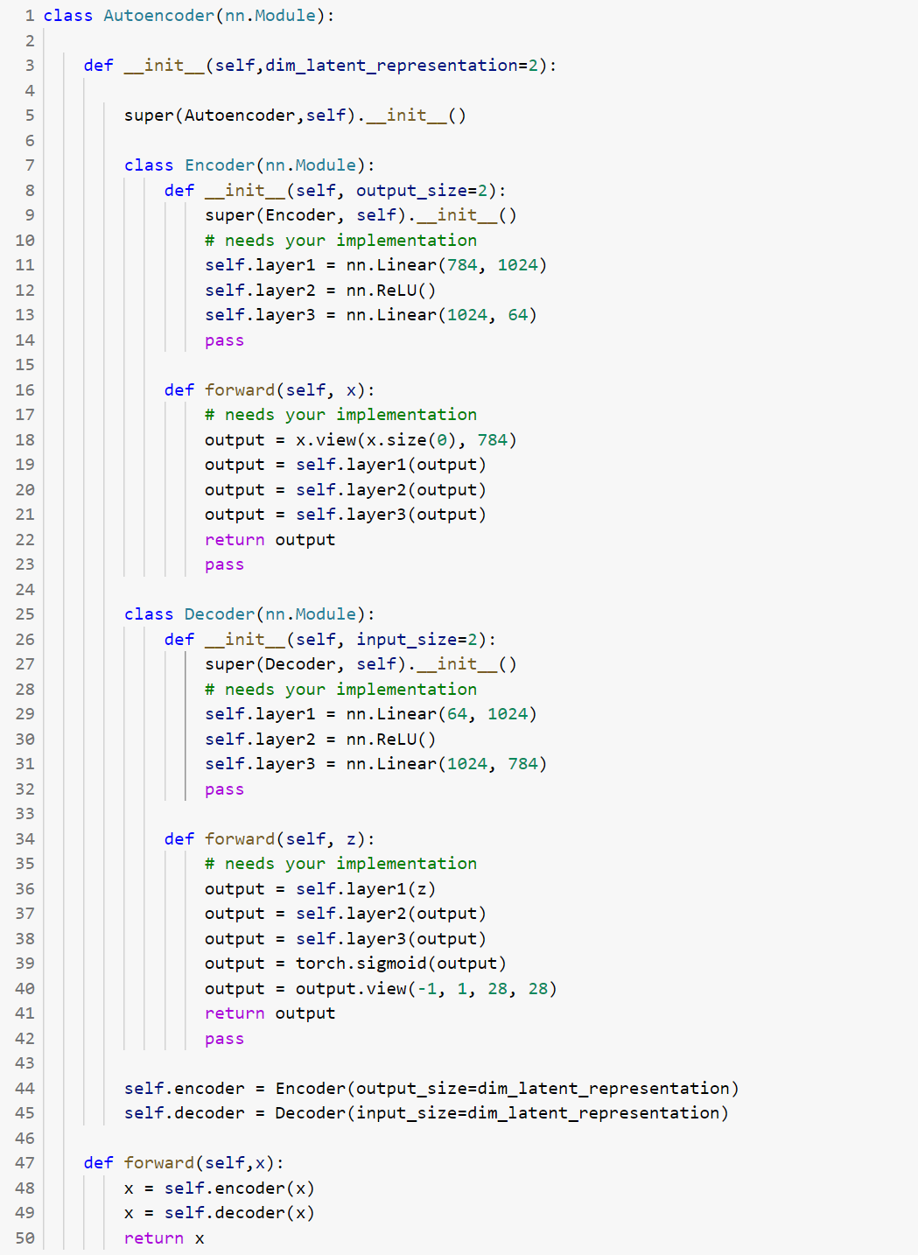

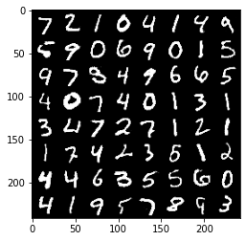

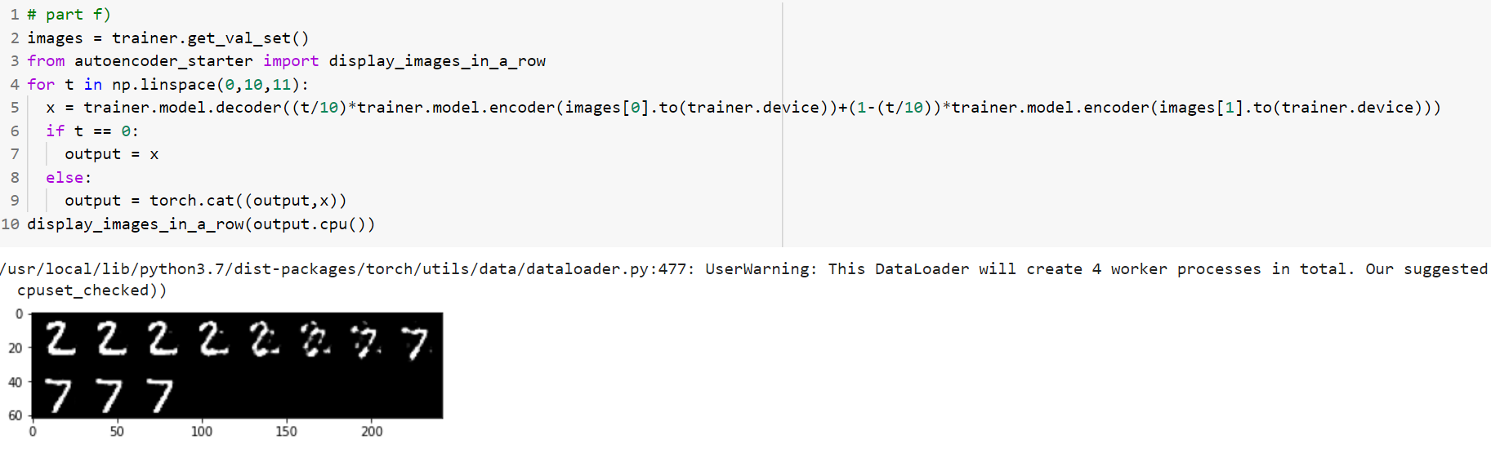

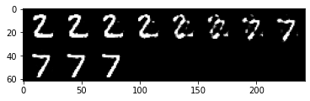

The image of model from part f is even more like numbers than the model from part e, the first four images in part f look exactly like “2”, and the last four images in part f look exactly like “7”, because it has even more dimensions, so that the accuracy is higher.